MBraun Glove Box
MBraun Glovebox

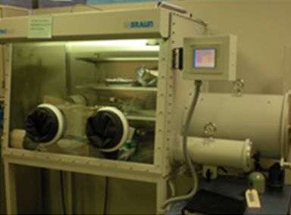
Potential Hazards while performing these activities
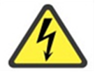 Electrical Hazard | This equipment is operated on a high voltage system and may remain charged after being powered off
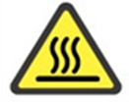 Heat Hazard | Some models have vacuum ovens installed. The ovens produce heat and may cause burns. Use caution around oven or other heat sources.
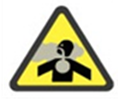 Suffocation Hazard | There is a risk of asphyxiation when working with inert gasses.
General Hazards | Depending on the type of work being performed in the box, thermal, mechanical, electrical, and/or chemical hazards may be present.

Preventions to reduce exposure to hazards:
Eye Protection | Wear safety glasses with side shields while operating equipment and working in laboratory.
Protective Gloves | Wear appropriate gloves for heat and chemical usage over top of glove box gloves. Keep glove box gloves away from hot surfaces
Read Manual | Become familiar with this guide before operating.

Note:
If you have questions about the operation of this equipment contact the LSM.

Setup/Operation Steps | Pictures
- Look at the Main Screen. H2O and O2 should be less than or equal to 10. If the values are not as indicated above please contact the LSM.  Note: Pressing “END” on any other screen will go to the Main Screen. | 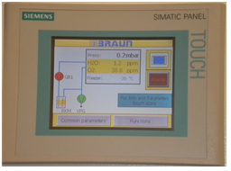
- Press the “Functions” button to access the screen that will allow you to light the work area. Touch the “Box light” button. | 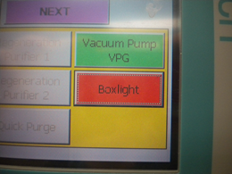
Remember: You must always wear a set of gloves over top of the glove box gloves to protect them from chemical contamination. Choose gloves that are appropriate for the chemical you are using. | 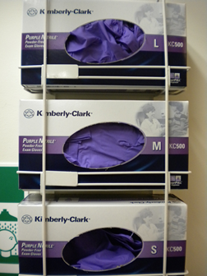
- Verify the pressure gauge on the chamber is reading 0, and the inner door is closed. | 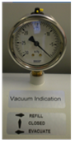
- Open the outer door by turning the knob counterclockwise, you will hear a pop, lift up to open. Slide the tray out, place materials on it. Make sure you open all bags and loosen lids, as they will be under pressure and may pop. Slide tray back in, reseal the outer door (you will hear a hiss). Ensure arm is over the post for the doors, or the atmosphere will be compromised. | 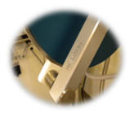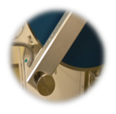
- On the main screen, select the chamber icon.
- For automatic evacuation/refill select the “Automatic” button.
- Select the red “Evacuate/Start Auto” button. The button will turn green and the chamber will cycle through evac/refill three times. When the cycles are finished, the button will turn red and the top of the screen will read: “Step 0, No antechamber cycle active” | 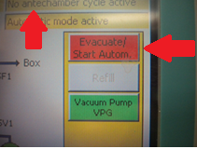
- Ensure the pressure gauge reads 0. Open the inner door of the glove box and transfer items into the glove box. Close the inner door and turn the knob (you will hear a pop when door is shut). | 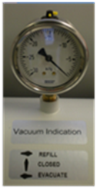
- Select “END” to return to the main screen. Select “Functions”. Check that the analyzer and the circulator are on. “Analyzer” and “Circulation Purifier 1” buttons should be green. If red, press to turn on. | 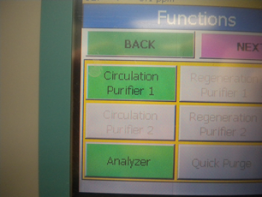
- To remove items from glove box, check that the gauge reads 0, open the inner door, and place items on tray. Close inner door securely by turning knob (you will hear a pop, and then open the outer door to remove items. Close outer door and turn knob (you will hear a hiss). Remember: The arm must be over the post on both the inner and outer doors, or the atmosphere will be compromised. | 